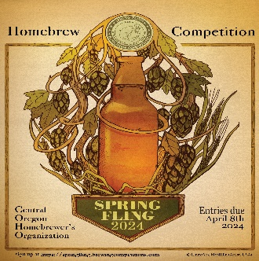
Spring Fling 2024 – Where You Can Help
Spring is in the air (some days ???) and it’s time for our big fundraiser of the year. We’re are focused on building on the success of last year and growing Spring Fling to become the biggest & best Home Brew Competion in the Pacific Northwest. To do this, we need help from the club. Below is information on the the different teams, what they do, and who to contact if you would like to help. If you have any other questions or concerns, please contact Pete on (760) 626-8386 or postner15@gmail.com
Judging Team – Randy Scorby
- Delivering largest value add for all participants
- Recruiting the most judges drives better time management & results
- Having BJCP certification is nice, but not necessary. Some prior judging experience is required
- Looking to recruit at least 12-15 judges
Steward Team – April Skrak
- Ensuring that the competition runs smoothly
- Moving entries / supplies to & from judges
- Ensuring judging paperwork is properly collected & entered
- Making sure entries flow to and from the Cellar Master
- Supporting daily setup/teardown
- Looking for about 8-12 stewards
Admin/Registration Team – Bobby Guzman
- Managing Competition Website (including publishing results)
- Handling Registration and Financial Matters
- Providing Computer Support – including labeling
- Looking for 1-2 helpers
Cellar Master Team – Tim O’Brian
- Collecting entries
- Organizing entries for easy access
- Getting & manning refrigerator truck during competition
- Ensuring entries get to Stewards/Judges
- Looking for 3-4 cellar masters
Food Team – Pete Ostner (for now, but looking for a volunteer to head up the team.
- Planning Menus for Competition meals
- Purchasing , picking up and laying out Meals
- Managing the Downstairs Sunshine room including set up/ clean up /tear down
- Looking for 3-4 food helpers
Media/Outreach Team – Sean Rochette
- Creating online outreach to reach potential entries
- Supporting online presentations
- Running the social media awareness campaign
- Looking for 2-3 marketing helpers
Utility Team – Kevin Tucker
- Providing backstopping support to all teams
- Coordinating setup/teardown
- Conducting raffle
- Looking for 3-4 “fire-fighters” to step in where needed
Competition Organization Team – Pete Ostner
- Coordinating all pre & post competition activities
- Getting sponsors and collecting donations
- Supporting marketing activities
- Organizing all competition event activities
- Point of Contact to the COHO executive board, AHA/BJCP and OSHBOTY
- Looking for 1-2 crazy people to assist

